Early History
from the formation in 1835 to the building in 1905

First Presbyterian Church PC(USA)
Grenada, Mississippi
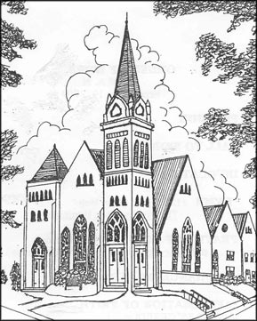

for Buddy
Early History
from the formation in 1835 to the building in 1905
First Presbyterian Church PC(USA)
Grenada, Mississippi

Session minutes were lost in a fire in May 1905 (stored in the Courthouse during construction of the new building).

Clearing up some misconceptions

That the Grenada church was organized by Rev Ebenezer McEwen, as given by Wallace Sherwood in the Grenada Sentinel and in the Presbytery’s Churches of St Andrew, is incorrect. The Annual Report of the Board of Missions of the General Assembly of the Presbyterian Church in the USA (1838) and Salem Presbytery Reporter, Vol 1, Issue 1 (1850) both note that the first minister at Grenada was John Black, appointed on December 7, 1836. McEwen organized the College Hill church in 1836 but had no association with Grenada or the Choctaws.
Eliot Mission was located on Cane Creek (Sections 26 & 27) about 3 miles up from the Yalobusha River - about a mile south of what is now Holcomb, west of Grenada – not at present-day Elliott (southeast of Grenada).

Another misconception is that the original church building burned. This building, erected in 1838 on the site of the present building, served until being demolished in 1904 to make way for construction of the present building. There were two disastrous downtown fires during the life of the original building, but it was not touched. The church records did burn in 1905, but while being stored in the courthouse during construction of the present building.

Finally, that the 1878 Yellow Fever epidemic reduced the church to 6 members is not correct. There were 32 who died, with 37 surviving, though these figures may not be complete. The minister and nearly half the congregation was lost – a devastating blow that the church survived.
BACKGROUND
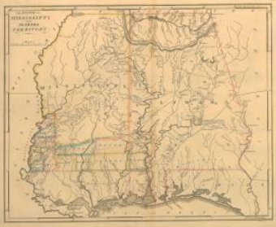

Mississippi at statehood in 1817

Everything north of the 14 southern counties from Natchez down and across to the Gulf Coast was Indian territory – wilderness with scattered Indian villages and a few trading posts.

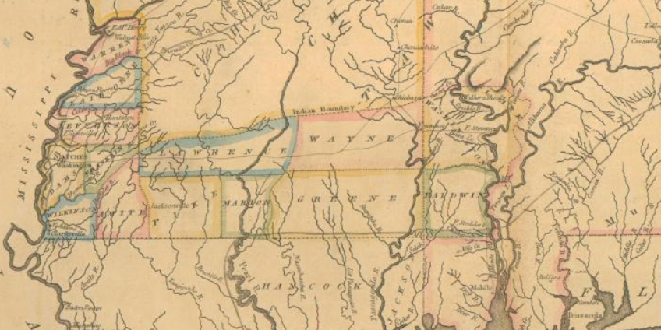
Eliot Mission (Choctaw) was established in the Choctaw Territory near present-day Holcomb by Presbyterian missionaries from New England in 1818 – in the year after statehood - and it operated until the Choctaws were relocated to Oklahoma in 1831-3. The Eliot church was received into Presbytery on October 25, 1830, on petition of its minister Rev Harrison Allen, but was removed from Presbytery roll in 1835 after the Choctaw removal. Harrison Allen had died in 1831. The mission was abandoned in 1832, with most of the missionaries either accompanying the Choctaws to Oklahoma or otherwise moving away. But a few stayed and bought land in the area.

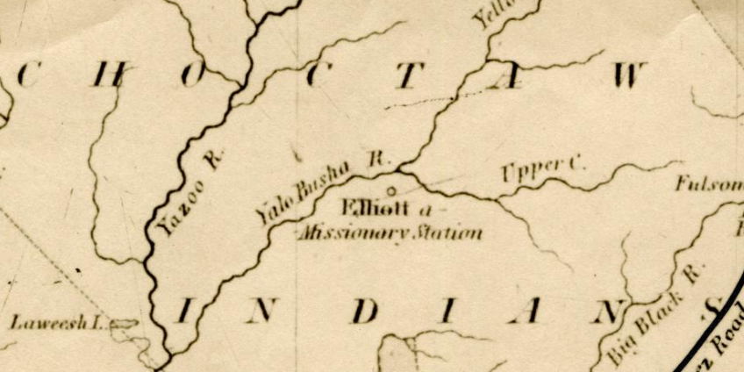

The Treaty of Dancing Rabbit Creek, signed in 1830, opened the Choctaw land, including all of what now is Grenada County and surrounding counties, for sale in 1833. The country was essentially wilderness then, with scattered now-abandoned Choctaw towns and minimal cultivation. Two adjacent towns – Pittsburg (west of Line Street) and Tullahoma/Tallahoma (east of Line) – on the Yalobusha River emerged from this sale - with lots surveyed, land cleared, and buildings erected.
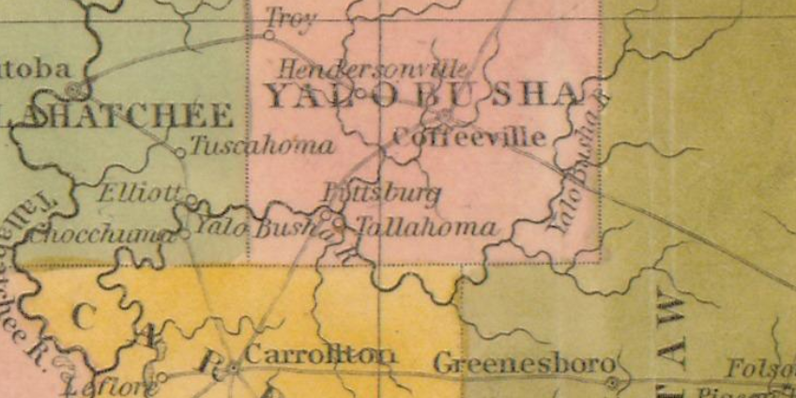
The two rival towns merged in 1836 to become Grenada.
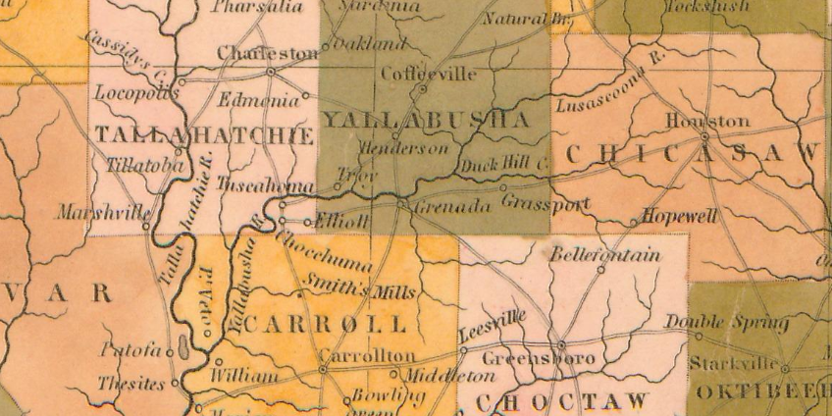
What is now the Presbytery of St Andrew developed from three predecessors – Clinton, Tombigbee (Tombeckbee) and Holly Springs. The original Presbytery of Mississippi was organized in 1816 by the Synod of Kentucky, encompassing the old Mississippi Territory and extending west of the Mississippi River. After the Choctaw cession, in 1831 the Presbytery of Clinton was set off from the Presbytery of Mississippi to cover Central Mississippi. In 1837-1838 it was divided through the controversy between the Old and New School parties of the Presbyterian Church, for a long time there were two Clinton Presbyteries, the New School (Grenada) being called South Lexington in 1846. Tombigbee Presbytery was organized in 1829 and included the area north of Clinton Presbytery, with its name changing in 1902 to East Mississippi Presbytery. St Andrew Presbytery was created in 1961 including parts of Clinton, Tombigbee, and Holly Springs Presbytery (organized in 1841).
In the Old/New School Presbyterian split of 1837, Grenada was New School.

FORMATION

The founder of the Grenada church was arguably John Smith, a lay missionary from Goshen MA who came to Eliot Mission in 1821. He was born in Goshen MA in 1777 and married Hannah Putney there in in 1802. They came to Eliot Mission from Goshen in 1821 with 5 children. He was the Superintendent for Secular Affairs (he ran the farm and physical plant) at Eliot Mission until it closed in 1832 after the Choctaw removal. After Eliot he bought land in 1833 in Pittsburg and built the Pittsburg Hotel (later Union Hotel) at the corner of College & Union (still standing). Initial meetings of those who formed the church were held at the hotel.
John Smith presented the request for organization of the church at Presbytery in 1835. The church continued to meet at the hotel until the first building was erected in 1838. He died in Grenada in 1845 and is most likely buried in Pine Hill Cemetery. After his death, his wife Hannah returned to MA and died there in 1866. Their children in Grenada married into the Methodist Church, so his family did not continue in the Grenada church, hence there are no memorials to him in the present church.
The Minutes of Clinton Presbytery (October 15, 1835) state that, “A petition from certain persons in and near Pittsburg, Miss. Requesting to be organized into a Presbyterian Church was received”. And on April 3, 1836, “The Committee appointed to attend to the request of certain petitioners presented at the last meeting, reported the organization of the Church of Grenada (November 29, 1835) consisting of six members” with John Smith and John Wright as Ruling Elders. The report was accepted and adopted. John Smith appeared for the Grenada church and “took his seat as a member of Presbytery”.
Rev John Black was the first minister commissioned December 7, 1836. John Black was born in Westmoreland County PA in 1809. He was educated at South Hanover College IN. After college he went to Natchez as a teacher. He got his theology degree from Oakland College and was licensed at New Orleans in 1836. Grenada was his first pastorate with seven members, growing to 80 by 1838 with the church building in place. He moved to the new church in Lexington after Grenada. (Salem Presbytery Reporter, Vol 1, Issue 1, p.14-15, 1850).
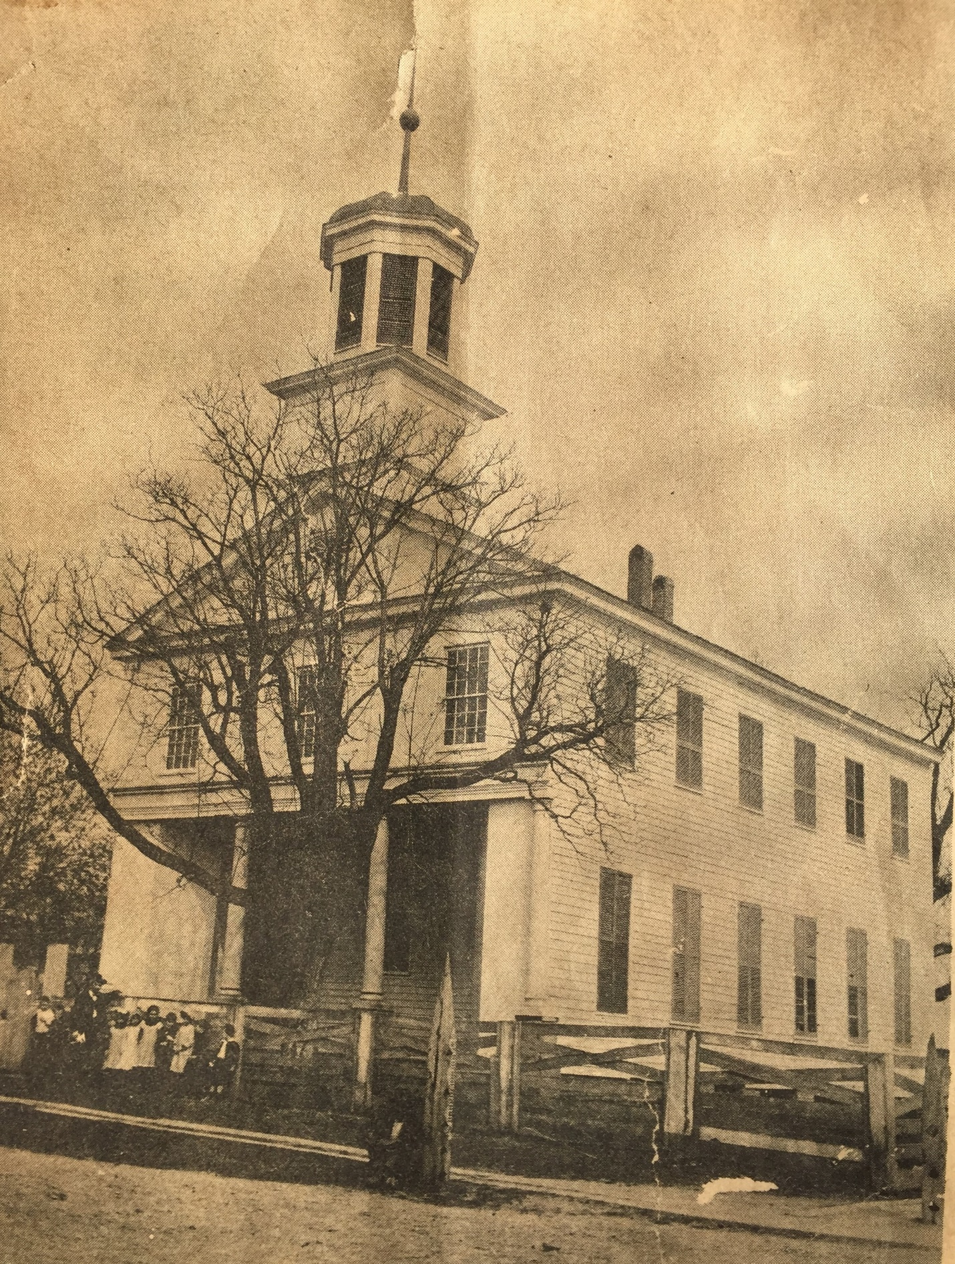
The first building was built in 1838 – a two-story wood building, with the second story serving as the Masonic Lodge.
The lot (113, later lot 114 was added) was purchased on January 16, 1838 – the first church lot in Grenada. The building, built by John Moore, faced west on the site of the present building. In 1894, the building was said to be “though not an attractive building outside, is very comfortable and handsomely furnished and seated within”. An interior sketch survives from an 1887 wedding invitation.

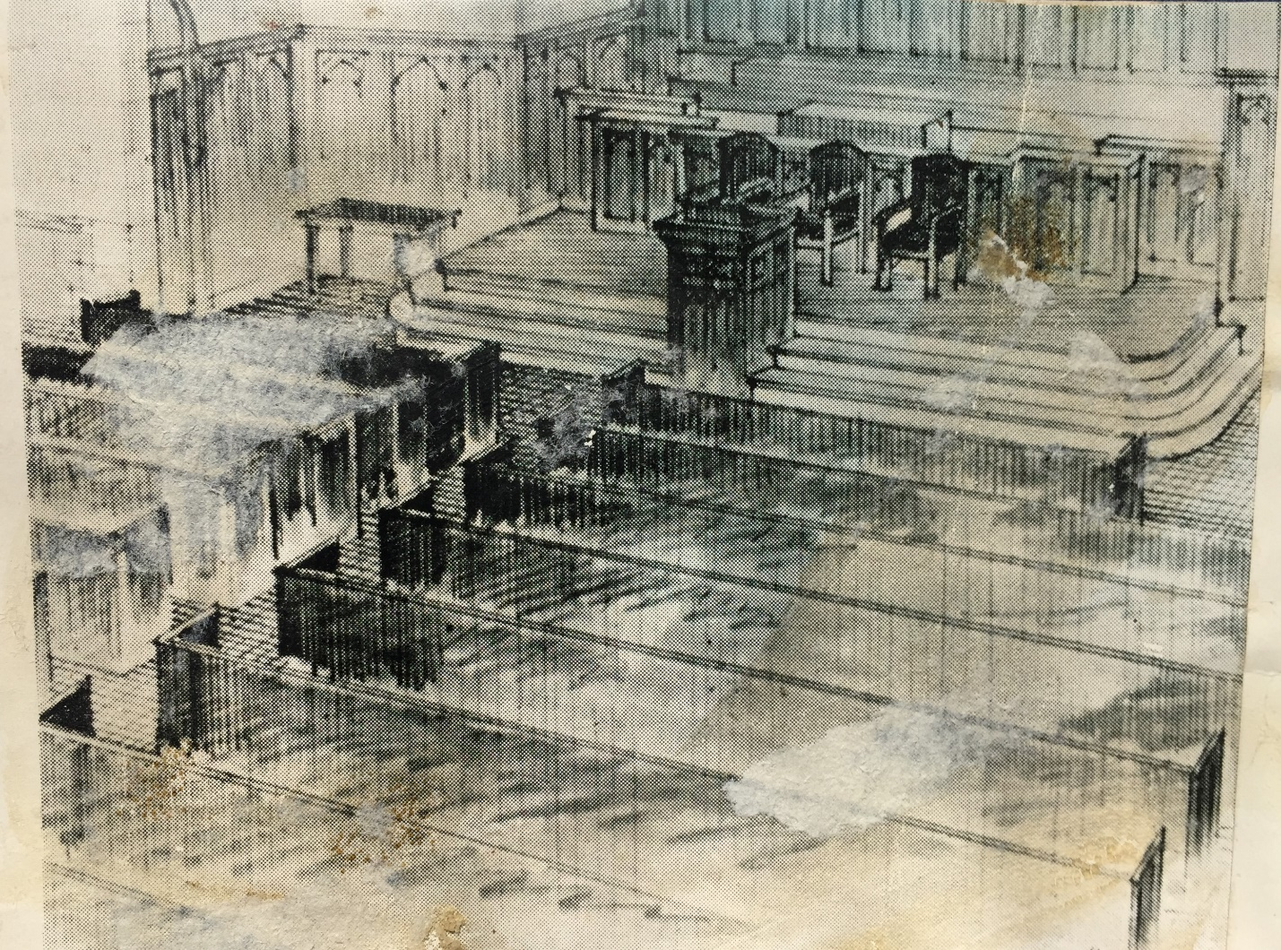

The building was a major meeting place during the years after the Civil War. It served until being demolished in 1904 to make way for the present building.

EARLY MEMBERS

The original six members in 1835 were perhaps the following (based on being an 1838 Trustee and an original land purchaser in the 1833 sale from the Choctaw cession). The numbers at the end of each entry throughout refer to presence in the Census.
John Smith
Dr John Wright
George K Morton
Nathaniel S Neal
Rowland Thornton Bryarly
Dr Allen Gillespie

John Smith (1777-1845) of MA was the Superintendent for Secular Concerns at Eliot Mission – he ran the farm. He married Hannah Putney in MA in 1781, and they came to Eliot Mission in 1821 with their five children from the church in Goshen MA. After Eliot closed in 1832, he built the Pittsburg Hotel (later called Union Hotel) where the initial meetings of the church were held. He appeared before Presbytery to petition for the organization of the church in 1835. He was an original Trustee of the Grenada Female Academy in 1839. He died in 1845 in Grenada, likely buried at Pine Hill Cemetery. Hannah returned to MA and died in 1866. 40
Dr John Wright (1801-1847) of NC was a physician educated in New York. A physician in NC, he moved to Greensboro AL before 1833 and then to Carroll County before 1835, the part that is now in Grenada County SW of Grenada. He married Sarah Dunn in NC before 1832. He joined John Smith in the petition to Presbytery. He died in Carroll County. 40
George K Morton (1803-1860+) of PA was a lawyer and merchant on the Tullahoma town square. He married Nancy Caruthers in Lexington TN in 1830. He was an original Trustee in 1839 of the Grenada Female Academy but was removed from office in 1846. He was a partner in the Grenada Savings Institution, formed in 1838 and collapsed in 1839 (MS Supreme Court suit in 1845). He moved to Coahoma County between 1840 and 1850 and was a judge in 1854. He married Eliza Craven in Coahoma County in 1850. He was Mustering Officer for Company B of the 18th Mississippi Cavalry in 1862. 40
Nathaniel S Neal (1812-1858) of TN was a merchant on the Tullahoma town square with land at Graysport. He married Martha M McLean in Carroll County in 1837. He is in the 1840 Yalobusha County census and the 1850 Carroll census. Buried in the Old Middleton Cemetery just west of Winona, between HW 51 and I55. 40 50
Rowland Thornton Bryarly (1813-1866) of VA was a merchant in Pittsburg, a commissioner of the Grenada Railroad Company incorporated in 1836. He never married. He was a partner in the Grenada Savings Institution, formed in 1838 and collapsed in 1839 (MS Supreme Court suit in 1845). 40
Rowland Thorton Bryarly is a bit of an enigma. He was born in VA in 1813 into a Presbyterian family. He was a steamboat man on the Red River (Red River County, across the river from the Choctaw land) in TX. He had several land grants in Red River County TX (1837) and bought 25 parcels of land in Yalobusha county (1833) all around the county. He is in the 1840 Yalobusha census, but at 40-50 - and in the 1860 Red River census but born in 1805 in AL. He delivered supplies to the Texas Militia in 1838. His Grenada County land was sold for debts in 1841-1842 and he went bankrupt in 1842. But he was engaged by New Orleans merchants for cotton sales in north MS in 1843 – and with the same New Orleans merchants for shipments in 1844 in Texas.
Since he was in TX and MS at the same time (1837-1839), perhaps he operated steamboats on the Yalobusha and the Red River. Perhaps he was involved in the Choctaw removal by steamboat from the Yalobusha to the Red? In 1831-1833 steamboats did transport Choctaws from Mississippi to the new Indian Territory on the north side of the Red River in OK – and returned to Mississippi with land speculators. And the Yalobusha County Choctaws relocated to just across the Red River from Bryarly’s Texas land. He later went back to TX and gave a false birthplace and birthdate in the 1850 Red River County census, perhaps hiding identity. His brother William Colville Bryarly was postmaster in Graysport from at 1846 or before to 1850 or after. Rowland died on a business trip to NY in 1866 and is buried with his ancestors in VA.
Dr Allen Gillespie (1801-1869) of TN was a physician in Pittsburg. He got his MD from Transylvania University (KY) in 1824. He then served as an assistant surgeon in the Army of the Southwest. He married Charlotte Robb in TN in 1829 and moved to Pittsburg by 1834. He was a pioneer in the use of quinine against malaria. He died in 1869 and is buried in Odd Fellows in Grenada. His wife, Charlotte, died in the 1878 yellow fever epidemic. 40 50 60

There were seven members when John Black became the first pastor in 1836, and the seventh was perhaps John Moore who built the first building in 1838.
John Moore (1810-1891) was born on May 22, 1810, in Nottoway VA, son of Thomas Moore and Sylvania Wilkinson. He married Mary Frances Jones in 1835 in Nottoway VA. He came to Grenada around 1836. He built the first church building in 1838 and constructed some of the more prestigious houses on Margin Street, including the Golladay/Townes house and others. He built the Whitaker house on Margin for himself. Mary Moore died in 1876 (Odd Fellows). He died on July 10, 1891, in Grenada and is buried at Odd Fellows Cemetery. He is in the 1850 Yalobusha census and the 1870 and 1880 Grenada census. The large window on the west side is a memorial to his family. 50 70 80

Trustees for the first building in 1838 were the following:
George K Morton
John Moore
Nathaniel S Neal
L C Caldwell
R T Briarly/Bayarley/Bryarly
Uriah Tyson
Ebenezer Parker Stratton

Uriah Tyson was associated with the Tullahoma town proprietors in 1833-34, had a lot on the square, and was a commissioner of the Grenada Railroad Company incorporated in 1836. He was a church Trustee in 1838 for the lot purchase. He had a warehouse at the steamboat landing on the Tallahatchie in Panola in 1843, for receiving and forwarding. He is not in the Grenada County land plats, and the only Uriah Tyson in the Mississippi census one born in 1846 in Copiah County to a Jesse Tyson. Uriah Tyson apparently did not stay long in Yalobusha County.
Ebenezer Parker Stratton (1812-1880) was born in Vermont and moved to VA as a boy. From there he went to Mississippi as a young man. He was a Presbyterian of strong convictions, a Sunday school superintendent for more than forty years. He was a church Trustee in 1838 for the lot purchase. He married a Wilson in Grenada in 1838 and she died in 1844. In 1848 he married Harriet Washburn in Yalobusha County, who survived him several years. He was a Trustee of the Grenada Female Academy, but not in the Grenada County land plats. He is in the 1840 and 1850 Yalobusha County census, but in Amite County (Liberty) in 1860. He died in 1880 and is buried at Magnolia (Pike County). 40 50
L C Caldwell is nowhere to be found.

The possible early members over the years covered in this history, in addition to those already noted above, are listed here in approximate order based on arrival in the Grenada area and by birthdate for the later generations. Although no membership rolls survived the 1905 fire, early members are indicated through being Trustees, having Presbyterian ancestors, funerals in the church, noted in genealogies, records, newspapers - or through connection with later surnames in the church. It is not always possible to determine if earlier ancestors actually became members, though. And it is not possible to determine the date when members joined the church.
Curtis Haywood Guy Sr (1799-1870) of NC was a planter on the west side of Pittsburg and later in the Tuscahoma region near Holcomb. He moved to TN and his first wife, Harriet Alexander of NC died in 1826 before he came on to Yalobusha County in 1834. He then married Eliza Scurlock Harper of TN who died in 1865. He was a prominent politician, active in state government. Despite his Presbyterian upbringing, he was not a member of any church. His daughter, Camelia, married Capt T H Mumford who ran the first steamboat up the Yalobusha to Grenada. Another daughter, Martha, married George Golladay. Two sons, Leander and Joseph, were in the 15th Mississippi in the Civil War, the former was killed at Atlanta. 40 50 60
Boyd McMurray Doak (1811-1878) was born in TN, the son of William Doak and Mary Polly McMurray. William Doak established Doak’s Stand on the Natchez Trace about 1812 where the Treaty of Doak’s Stand was signed in 1820. William Doak also had a Choctaw wife who was the daughter of Apukshunnubbee, one of the three great Choctaw kings. While Boyd Doak was white, he had a Choctaw step-mother and step-siblings who were half Choctaw. Boyd Doak took part in moving the Choctaws after the treaty and then moved to the Pea Ridge area of Yalobusha County in the early 1830s. He is in the 1840 Tallahatchie County census and the 1860 Yalobusha census. He was an active member of the Presbyterian Church. His wife died in 1844-45. He served in the Mexican War and died in the 1878 yellow fever epidemic. Boyd Doak’s son Robert (Episcopalian) built Doak Hardware in 1867 – now First & Green. Boyd Doak is buried at Odd Fellows. 40 60, Marshall 70
Ralph Coffman (1812-1878) of VA was a merchant in Pittsburg and a partner in the Grenada Savings Institution, formed in 1838 and collapsed in 1839 (MS Supreme Court suit in 1845). After the Civil War, he was an initial director of the Grenada public school system in 1871. He and his wife, Eliza J (1815-1887) both died in the 1878 yellow fever epidemic and are buried at Odd Fellows. 40 50 70
Robertson Horton Sr (1801-1878) was born in Wake County NC, the son of David Horton and Elizabeth Robertson. His brother, Littleberry, was a Baptist minister in NC. He went to Nashville, a carpenter who helped build the Tennessee State Capitol. He married Louisa America Ridley (TN 1815-1887) in Nashville in 1831, daughter of Thomas E Ridley and Margaret Harwood. In 1832 he was employed to bring stock and supplies to Yazoo County. Traveling through Yalobusha County, he was impressed with the Yalobusha country and on his return built a log cabin at Torrance (between the Yalobusha and Skuna Rivers in the present Carver Point area - the present Horton Road). He cleared 18,000 acres of land and built a larger home, the original house having burned, with John Moore of Grenada as foreman of twenty-four carpenters. His wife died in 1884. He and his wife are buried at the Horton Cemetery on Horton Road between the Yalobusha and Skuna Rivers, as is her father and three of the Horton children. There is a memorial window in the church for him and his son. He was Clarice/Leigh’s great-great-grandfather. 40 50
Judge Robert Davidson McLean (1810-1874) was born in KY and came to Yalobusha County in 1836. He married Mary Ann Whittaker (AL 1821-1869). He was mayor of Grenada for 25 years. He was an elder of the Presbyterian Church. Both are buried at Pine Hill Cemetery. 50
Robert Mullin (1818-1885) was born in Ireland. He left Ireland when only a boy and joined his sister in OH. He went to KY in 1829 and on to Yalobusha in 1838, near Troy. He established Evergreen Plantation in that area around 1850. He married Mary Frances Ledbetter Walton (TN 1824-1899) in Yalobusha County in 1843. He was a member of the three-person committee supervising relief efforts in the 1878 yellow fever epidemic. He was a Trustee in 1876. They both are buried at Odd Fellows. 50
The brothers Dr Green Crowder (1799-1867), born in Wake County NC, and Ransom Duke Crowder (1806-1863), born in Smith County TN, had substantial land in several areas of the county, including in Tullahoma and in the southern part of the county just north of the present Camp McCain. Their father, George Crowder, moved from NC to TN between 1799 and 1806. Green Crowder married Mary Hiatt Pope in Yalobusha County in 1839, who died in 1888. They were not Presbyterians. They are both buried at Odd Fellows. Ransom Duke Crowder married Virginia Ray in TN in 1835. They came to Yalobusha County from TN between 1838 and 1840. They are buried at the Crowder Cemetery (now abandoned) about a mile west of Crowder Creek and a mile north of Camp McCain. He was India’s great-grandfather. 40 50 60
James H Davis (1807-) was born in SC. He is in the 1850 Carroll County census with wife Mary and son William (14), but he had land north of Grenada in the Troy area. They came between 1838 and 1841. 50
Angus W Ayres (1816-1878) was born in OH. He married Urcilla McConnell (TN 1822-1861) in Carroll County in 1842. He came to Carroll County before 1840 and moved to Yalobusha by 1860. His wife died in 1861. Both are buried at Odd Fellows. There is a memorial window in the church for the Ayres family. Carroll 50, Yalobusha 60 70
Dr James M Townes (1809-between 1860 and 1870) He was born in VA and came to Yalobusha County before 1840. He was quick to make the switch from wrought iron to cast iron, then to steel for plows. He was Clarice/Leigh’s great-great-grandfather. 40 50 60
William Hooe Winter Jr (1817-1880) was born in Tuscumbia AL, son of William Hooe Winter Sr and Catherine Stark Washington, a cousin of George Washington. He moved from AL to Hinds County MS in the late 1830s and then to Yalobusha County around 1840, joining his older brother, Thacker Winter. He married Elvira Ann Brown (1821-1897) in Carroll County in 1845. By 1860 he owned land in Tallahatchie, Sunflower, and Coahoma Counties as well. He moved into the town of Grenada in 1858. He was a Trustee in 1876. They are both buried at Odd Fellows. He was the great-grandfather of Gov William Forrest Winter. 50 60
Robert E Knox (1806-1884) of NC came to Yalobusha County before 1840, likely with his brother Theophilus. His land was in the Graysport area. He married Susan Harriet McKee (died 1852, Knox Cemetery) in 1835 in NC, Nancy McDowell (died 1874, Knox Cemetery) in 1854 in Yalobusha County, and L A C Fielder in 1877 in Grenada. He is buried at the Knox Cemetery in Grenada County. His nephew, James M Knox, died in the 1878 yellow fever epidemic. 50 60 70 80
Theophilus M Knox (1812-1850/1860) of NC came to Yalobusha County before 1840, likely with his brother, Robert E Knox. He married Margaret J McRea (born in 1821 in NC) in Carroll County in 1840. He died between 1850 and 1860, and his children moved in with his brother, so it appears his wife had died also. Her father, James McRea, was living with them in 1850 and with brother Robert in 1860. 50
William Colville Bryarly (1815-1856) was born in VA in 1815 into a Presbyterian family. He was the younger brother of Rowland Thornton Bryarly, a Trustee for the church lot purchase in 1838, but no direct connection of William Bryarly with the Grenada church has been found. He went first to MD and then came to Yalobusha County in 1840, becoming the Postmaster at Graysport by 1846. He married Mary Caroline Lake in Yalobusha County in 1847, who had come to the county with her four brothers from MD in 1835. His grand-nephew Robert Presley Bryarly (22) was with him in 1850. 50
Septimus Caldwell (1818-1853) was born in Mecklenburg NC. Both his father, Rev Samuel Craighead Caldwell, and his grandfather, David Caldwell, were Presbyterian ministers, as was two of his brothers (one, Andrew Harper Caldwell, is buried at Senatobia). He came to Mississippi sometime prior to 1845. He was a lawyer and district attorney in Yalobusha County. He married Mary A Phillips (born 1827, died after 1910) in Yalobusha County in 1847. They both are buried at the Yellow Fever Cemetery. He had an older brother, Samuel Craighead Caldwell Jr (born 1810), and there is a Samuel C Caldwell in the original land plats. Although there is no doubt that the Caldwell Trustee on the 1838 deed is L C, one must wonder if this Trustee might have been Samuel C. 50
Zadock Perry Jr (1795-1849) was born in Lancaster County SC, son of Benjamin Perry and Mary. He married Dorcus Clance Duren (1801-1872) around 1821. They moved to MS in 1845. Both are buried on his plantation (Williams-Perry-Rosamond Cemetery on the south side of Grenada Lake on Wildlife League Road). Zadock Perry is the great-great-grandfather of Charles Perry from the church. Dorcus in Yalobusha 50, Oliver Hazard Perry adjacent.
Oliver Hazard Perry Sr (1822-1869) was born in Lancaster County SC, the son of Zadock Perry. He married Elizabeth Williams (1832-1848) in Yalobusha County in 1847, who died with their child in childbirth. He then married another Elizabeth Williams (1828-1868), his first wife’s cousin, in Yalobusha County in 1850. They were Presbyterians, and both are buried at the Parker Cemetery, just west of the Williams-Perry-Rosamond Cemetery on the south side of the lake. His gravestone is in error giving his father as Jeremiah. That Oliver H was in Pontotoc County (Oliver Hazard Perry was a common name at the time, and there were several in MS). He was the great-grandfather of Charles Perry from the church. 50 60
Morrison Thomas (1802-1872) was born in Edgecombe County NC, the son of Ichabod Thomas (1774-1826) and Susanna Barnes (1785-1844). He married Patience Barnes Horn (1805-1874) in NC in 1828. They went to Sumpter County AL around 1831 and came to Yalobusha County around 1849. They both are buried at Odd Fellows. 50 60 70
Thomas Powell (1825-1878) was born in Nottoway County VA, son of Thomas W Powell and Martha Anderson Leigh (1794-1860/70). After his father died in VA, his mother brought his children -Thomas, John, Mary and Cornelia - to north AL in 1831 and then on to Yalobusha County in 1836. Thomas served in the CSA cavalry and died in the 1878 yellow fever epidemic. He is buried at Odd Fellows. 50 60 70
Capt George Francis Ingram (1829-1902) was born in SC to a Presbyterian father and a Methodist mother. He married Rebecca Dorcus Perry (SC 1830-1864), daughter of Zadock Perry, in Yalobusha County in 1851. He came to the Graysport area of Yalobusha County in 1854. He married Sarah Jane Clayton (1835-1902). He was a Lieutenant in the 42nd Mississippi in the Civil War and fought at Gettysburg. Both he and his wife were Presbyterians. All are buried at the Ingram Cemetery in the Pea Ridge area of Grenada County.
Dr Green Woods Trimble (1821-1901) came from AL to Tallahatchie County in 1854, then to Duck Hill and Spring Hill, back to AL, back to Grenada in 1878. He married Rebecca S Bullock (SC 1826-1898). His daughter, Molly, married Curtis Haywood Guy Jr. They are buried at Odd Fellows. Tallahatchie 60, Grenada 80 00
Richard Jabez Nason (1817-1886) was born in SC, son of Richard Nason (Ireland 1776-1862) and Margaret Milling (SC 1784-1864). His parents are buried at the Hope/Owens Cemetery in the Nason area of Grenada County. He married Jane McDowell (1820-1856) in 1849, Margaret A Miller (1817-1879) in Pontotoc County in 1857, and Lucy D Mitchell (1839-1915) in Grenada in 1881. He served in Capt Stanford’s Mississippi Light Artillery in the Civil War. They are all buried at Spring Hill Cemetery in Grenada County. 50 60 70 80
Robert Highgate (1824-1888) was born in Scotland and came to Yalobusha before 1858. He married Jeanie M Stevenson in Scotland in 1832 and her parents, Robert and Janet (Thomson) Stevenson came with them. Her mother died in 1868 and her father died in the 1878 yellow fever epidemic, both buried at Odd Fellows. Robert Highgate was a house and sign painter. His wife is credited with holding the church together during the 1878 yellow fever epidemic. She died in 1897. They both are buried at Odd Fellows. The west window on the right is a memorial to them. 70 80
Robert Stevenson (1807-1878) was born in Scotland. He married Janet Thomson (1834-1868). He was a carriage maker, living with Robert Highgate in 1870 after his wife died. Probably father of Jeanie Highgate. He died in the 1878 yellow fever epidemic. Both buried at Odd Fellows. 60 70
Capt Alex Fraser (1832-1897) was born in Canada where his parents were Presbyterians from Scotland. He came to Mississippi as a timber contractor for the Illinois Central Railroad before the Civil War and married Margaret Crowder, daughter of Green and Mary Crowder, in Grenada in 1869. She died in 1910 (Odd Fellows). He ran the blockade between Greenville and St Louis during the Civil War. He established a plantation near Elliott Station in 1872. He was a Presbyterian though his wife was a Baptist. He is buried at Odd Fellows.
Dr James B Gage Sr (1835-1898) was born in Alabama, the son of Rev James B Gage (Baptist) and Permelia James Sanders of GA. His parents came to the Torrance area of Yalobusha County in 1839. He married Eleanor Tabitha (Ellen) Perry (1838-1918), daughter of Zadock Perry, in Yalobusha County in 1868 and was a physician. Rev and Mrs Joseph C Carothers lived with the Gage’s as he started his ministry at the church. James Gage’s wine died in 1883. They both are buried at Odd Fellows. 50 60 70 80
J William Berry Jr (1835-1898) was born in VA, son of William Berry Sr (VA 1803- 1860/70) and Maria M Vaiden (VA 1805-1875). His father came to Yalobusha County before 1840. William Jr married Laura Maude Whitaker (1857-1895), sister of Dr William Henry Whitaker, in Grenada in 1875. They and his mother are buried at Odd Fellows. 50 70 80
Dr John Leander (James) Milton (1823-1878) from SC was a dentist who came to Lexington MS in 1841 and then to Grenada after 1865. He married Susan (Sue) Legrand (TN 1831-1857) in Holmes County around 1849. She died in 1857 (Odd Fellows) and he married Frances Jennie Moore (TN 1835-1871) in Yalobusha County in 1859. She died in 1871 (Odd Fellows). He was mayor of Grenada during the 1878 yellow fever epidemic and one of the first victims. He was a Trustee in 1876. Likely buried at Grenada, but grave not found.
Samuel H Cowles (1826-1870) was born in NH, son of Levi Cowles and Polly Hurd. He married Sarah (Sallie) W Walton (1834-1883) in Yalobusha County in 1852. They lived in the Troy area and the children attended school with a tutor at Evergreen Plantation. They both are buried at Odd Fellows. He was the great-great-grandfather of Clarice & Leigh. The window on the right on the south side is in memory of Samuel and Sarah Cowles. 50
William Drake Salmon Sr (1833-1909) was born in SC. He married Mary Griffis (SC 1834-1907). They lived in the Hardy area. Both are buried at Odd Fellows. Sunflower 70, Tallahatchie 80, Grenada 00
Capt Richard Neal Hall (1834-1892) was born in NC. He married Sarah J (NC 1846-1917). He was the Grenada County sheriff in 1880. Both are buried at Odd Fellows. Tallahatchie 60, Grenada 80
Adrian Van Brocklin Thomas (1835-1891) was born in Sumpter County AL, son of Morrison Thomas and Patience Horn. He came to Yalobusha with his parents in 1849. He married Mary Elizabeth/Eliza Nason (SC 1838-1910) in Yalobusha County in 1856. They were in Tallahatchie County in 1860 and then in Grenada. He was in the 2nd Mississippi Cavalry in the Civil War. He was a merchant and Chancery Clerk in Grenada County, and a director of the Merchants Bank. He was a Trustee in 1876. Both are buried at Odd Fellows. 50 60, Tallahatchie 80
William B Davis (1835-1885) was born in AL, son of James H Davis. He married Nannie/Annie C (SC 1840-1902) before 1862. Both are buried at Odd Fellows.
William Edmondson Smith (1837-1922) was born in Alabama. He married Katie Moore (1851-933), daughter of John Moore, in MS before 1867. They were living with John and Mary Moore in 1870. He was a member of the Building Committee in 1901 & 1904. Both are buried at Odd Fellows. 70 80
Permelia Statham Dudley (Mrs Bryon J Dudley) (1837-1916), mother of Dr B S Dudley. Her parents were Dr Augustin Davis Statham (GA 1807-1862) and Lucy Bullock Tate (1808-1856). They moved to Yalobusha County from Wilkes County GA around 1842 and are buried at the Green Cemetery in the Riverdale area. Born in GA, she came to Yalobusha County as a child around 1842. She married Bryon J Dudley (NH, died 1867, captain in 15th MS) in Yalobusha County in 1857. Her brother was CSA General Walter Scott Statham who died at Vicksburg in 1862. She is buried at Odd Fellows. 50 60 00
John Thomas Parker (1839-1901) was born in Calhoun County, son of William B Parker (1812-1875) and Isabella Franklin Harris (1817-1884) of NC, married in 1839. His parents are buried at the Chapel Hill Cemetery (Big Creek) in Calhoun County. His father came from NC to Lowndes County after the marriage and then to Carroll County in 1842. John Thomas Parker served in the 15th Mississippi and after the war married Martha Ann Clark (1848-1884) in Yalobusha County in 1866. After his wife died in 1884, he married her sister, Laura Clark. He and his family were Presbyterians. He is buried at the Parker Cemetery in Grenada County, Martha at Mt Nebo Cemetery, east of the lake.
James B McCord (1840-1888) and Mary Elizabeth Coffman (1842-1915) were married in Yalobusha County in 1867. They were living with her father, Ralph Coffman, in 1870. Both are buried at Odd Fellows.
Judge Archibald Thomas Roane (1841-1922) was born in Lafayette County MS, son of Dr Andrew Campbell Roane (TN 1796-1874) and Sarah Jane Hackney Clark (KY 1813-1890). Dr Roane, son of the governor of TN, came to Yalobusha before 1840 and later lived in Lafayette and Calhoun Counties. Archibald Roane married Mary Elizabeth Morrison (1844-1884 born in Tishomingo County MS) in 1865. They came to Grenada County between 1880 and 1884. He was a member of the Building Committee in 1901. After she died in Grenada (buried in Pittsboro) he married Katherine (Kate) Elvira Winter (1852-1931), daughter of William Hooe Winter, in Grenada in 1886. They are buried at Odd Fellows. Lafayette 50, Calhoun 70 80, Grenada 00 20
Dr John Edward Hughes (1842-1911) was born in MS, son of Edward W Hughes (VA) and Mary H (NC) who came to Yalobusha County before 1840. He married Maggie Calhoun (1863-1927) in Tallahatchie County in 1884. He was in Stanford’s Battery, Mississippi Light Artillery in the Civil War. They are buried at Odd Fellows. 50 60 70 80 00 10
Curtis Haywood Guy Jr (1843-1909), born in Yalobusha County, had a substantial plantation about 11 miles west of town in the Holcomb area, settled by his father, Curtis Haywood Guy Sr, in 1834. His grandparents were strong Presbyterians in NC, later AL. He married Ione Thomas (MS 1851-1875) in Tallahatchie County. He then married Mary/Molly Trimble (MS 1856-1929), daughter of Dr Green Woods Trimble, in Grenada in 1876. He was in the 15th Mississippi Cavalry in the Civil War. He was on the Forrest raid on Memphis and was one of the nine who rode into the lobby of the Gayoso Hotel. He was active in politics and was a member of the Building Committee in 1901. They all are both buried at Odd Fellows. 50 60 70 80 00
William I Ayres (1843-1878) was born in Carroll County, son of Angus W Ayres. He was still single and living with his father in Grenada County in 1870. He married Mary Elizabeth Hart (MS 1844-1904) in Carroll County in 1876. She was a teacher. Her father was born in IN/TN and her mother in KY. William died in the 1878 yellow fever epidemic. Both are buried at Odd Fellows. She has a memorial window in the church. Carroll 50, Yalobusha 60 70
John J Weyneth (1831-1904) was born in Switzerland. He went to TX, then to Yalobusha County in 1868. He married Augusta F Gaul (Germany 1841-1898) in TX. Both are buried at Odd Fellows. TX 60, Grenada 80
Augustus Samuel Lochman Weigert (1843-1929) was born in PA to German parents. He was in the Union Army in the Civil War and came to Grenada County after the war, a blacksmith. He was living with Robert Highgate in 1870 and married Margaret Bell Highgate (1859-1910) in Grenada in 1876. Both are buried at Odd Fellows. 70 80 10 20
James M Knox (1844-1878) was born in Yalobusha County, son of Theophilus Knox and Margaret J McRea of NC. He was living with his uncle, Robert E Knox, in Yalobusha County in 1860. He was a dry goods merchant in Grenada, single, living in a boarding house in 1870, and died in the 1878 yellow fever epidemic.
John Leigh Townes (1844-1930/1940) He was born in Yalobusha County, son of James M Townes. He was in the 29th MS in the Civil War. He married Sallie J Slack in Yalobusha County in 1867 (born in 1848 in MS). She died between 1920 and 1930. He is buried at the Leigh Cemetery, north of Grenada, toward Coffeeville. He was Clarice/Leigh’s great-grandfather. 50 60 70 80 00 10 20 30
Eleanora (Ella) V Elam Allen (1844-1920) was born in Carroll County and married James H Allen in Carroll County in 1882. She is buried at Odd Fellows. 60 80 Montgomery (Winona) 00
Robertson Horton Jr (1846-1904) was born at Torrance in Yalobusha County, son of Robertson Horton Sr. He married Ellen Augusta Cowles (1854-1930) in Grenada in 1878, daughter of Samuel Hurd Cowles and Sarah Walton. He was in the 3rd Mississippi in the Civil War. He was a lawyer, mayor of Grenada in 1880-1882, School Superintendent in 1990-1992, and an elder in the Presbyterian Church, living on Margin Street. Both are buried at Odd Fellows. He was Clarice/Leigh’s great-grandfather. 50 60 70 80 00
William Harry Hart (1846-1878) was born in Carroll County, the son of Samuel Hart Sr (IN 1813-1887) and Amanda Ayres (-1890), married in Carroll County in 1842. Samuel Hart Sr moved to TN as a child and then came to Carroll County in 1836 where he was an elder in the Presbyterian Church. The parents are in the Carroll County census (North Carrollton) for 1850-80. Harry Hart was a CSA soldier and a traveling salesman after the war. He settled in Grenada and died in the 1878 yellow fever epidemic. And is buried at Odd Fellows. Carroll 50 60
Maj Benjamin Franklin Thomas (1846-1918) was born in AL, son of Morrison Thomas. He married Annie Nelson Poston (TN 1861-1945) around 1887. He served in the 15th MS in the Civil War, was a deputy sheriff and mayor of Grenada. Both are buried at Odd Fellows. 50 70 80 00 10
Dr John W Young (1846-1933) was born in the Teoc area of Carroll County, son of Samuel Hart Young (VA 1820-1861, Old Middleton Cemetery, Winona) and Catherine Weeden Small (TN 1826-1915, Odd Fellows) in Carroll County in 1845. His sister, Elizabeth Ann Hart Young (Carroll County 1856-1922, Evergreen Cemetery, North Carrollton), married John Sidney McCain (Carroll County 1851-1934, Evergreen Cemetery, North Carrollton), in Carroll County in 1877, the great-grandfather of Senator John McCain. John W Young married Mary Louise (Mollie) McCain (MS 1853-1902), a cousin of his BIL. He was a member of the Building Committee in 1901 & 1904. Miss Jane Young (1875-1962) was their daughter. They are buried at Odd Fellows. Carroll 50 60 70 80, Grenada 10 20 30
John William McLeod (1846-1906) was born in Lafayette County. He married Annie Elizabeth Buffaloe (1846-1921) in Marshall County in 1866. His daughter, Martha McLeod (1890-1946), married Otho T Eddleman (1872-1962). Their daughter, Elizabeth Miller Eddleman Grant (1912-2002), was the mother of Martha Grant. So John William McLeod was Martha’s great-grandfather. All are buried at Odd Fellows. Lafayette 50, Grenada 00
Charles M Coffman (1847-1878) was born in MS, son of Ralph Coffman. He married Margaret F Hughes (born 1850 in MS) in Grenada in 1871. He died in the 1878 yellow fever epidemic. 50 70
William Brown Winter (1847-1929), son of William Hooe Winter Jr, was born in Yalobusha County. At 16 he joined the 18th Mississippi Cavalry in 1864, part of the forces of Nathan Bedford Forrest, and was on the Memphis raid. He married Amelia P (Minnie) Fisher (1850-1920) in Yalobusha County after the war. His wife died in 1920. They both are buried at Odd Fellows. William Brown Winter was the grandfather of Gov William Forrest Winter. 50 60 80
Thomas Tingle (Tom) Hamilton (1847-1931) was born in SC, son of John McGill Hamilton (1816-1866, Vaiden) and Mary Caroline Clinkscales (1821-1894, Vaiden). He came with his parents to the Vaiden area of Carroll County between 1840 and 1850. He married Louisa (Lou) Prudence Johnson (1846-1878, Vaiden) and later her sister Isabelle (Belle) Johnson (1861-1943, Odd Fellows). Miss Tommye Hamilton (MS 1899-1972) was their daughter. They are buried at Odd Fellows. Carroll 50 60 70 80, Grenada 20
Walter B Wolfe (1848-1905) was born near Carrollton, son of Jacob V Wolfe (SC) and Maria S (SC) who came to Carroll County in the 1840s. He came to Grenada in the 70s. He married Emma A Townsend (MS 1860-1881) in Grenada in 1878. They and his parents are buried at Odd Fellows. Carroll 50 60 70, Grenada 80
William E Moore (1849->1910) was born in Yalobusha County, the son of John Moore. He was a carpenter, widowed and living with his sister, Susan A Moore, in Grenada in 1900. Her niece, Ludy, born in 1875 was there also (perhaps his daughter). In 1910 he was living in a boarding house in Grenada. He was a member of the Building Committee in 1901 & 1904. 70 00 10
Dr William Edward Tillman (1851-1925) was born in NC. He grew up in NC and came to Graysport in the 1870s, listed there in a medical registry in 1878. He married Eliza (Lizzie) Burns Willis (1858-1904) in VA in 1884. She was killed in a buggy accident while bringing their daughter to Grenada College. They are buried at Odd Fellows. 80 00 10 20
Judge William Campbell McLean (1854-1928) was born in Yalobusha County, the son of Judge Robert Davidson McLean. He married Susie Collins 1857-1902) and later Belle Chamberlin (1879-1944)). He was an elder of the Presbyterian Church and moderator of North Mississippi Presbytery in 1888 the first ruling elder to be elected moderator. He was active in state politics, was on the state Supreme Court, and was a delegate to the 1890 Constitutional Convention. He was a Trustee in 1876 and Chairman of the Building Committee in 1901. All are buried at Odd Fellows. 60 70 80 10 20
John Walton Buchanan (1855-1904) was born in Brooklyn NY, son of Francis Buchanan and Ellen Malconsin, both born in Ireland. His parents came to Woodville MS shortly before the Civil War. He got started in the newspaper business in Woodville and bought the Grenada Sentinel in 1877, becoming its well-respected editor for 26 years. He married Mannie Hood in the original church building in 1887. Their wedding invitation includes a sketch of the building interior. He is buried at Odd Fellows. His wife moved to MO in 1905. Wilkinson 70, Grenada 80 00
S A Lacock (1856-1930). He was born in MS, son of Dryden E Lacock (VA) and Sarah Ann McMurtry (MS), married in Adams County in 1852. His wife died in 1888. He then married Carrie Houston (1868-1949) in Grenada in 1891. His siblings died in the 1878 yellow fever epidemic. He is buried at Woodlawn, his parents at Odd Fellows. 60 80 10 20
Charles Elmore Perry (1856-1936) was born in Yalobusha County, son of Oliver Hazard Perry Sr. He is buried at Odd Fellows and was the grandfather of Charles Perry from the church.
William Render Yeager (1856-1918) was born in MS, son of Elijah Render Yeager (TN 1823-1887, Shiloh Cemetery, Big Creek in Calhoun County) and Sarah Jane Riley (AL 1827-1883, Shiloh Cemetery, Big Creek in Calhoun County). He married Henrietta Virginia Cotton (1860-1928) in Grenada in 1884. They are buried at Mt Nebo Cemetery, east of the lake toward Big Creek. 60 70 80 00 10
Dr William Henry Whitaker (1860-1931) was born in Tallahatchie County, son of Alexander Whyte Whitaker (AL 1825-1871, buried at Pine Hill) and Caroline M (born 1836 in TN). They were in Tallahatchie in 1860, Grenada in 1870 and 1880. He was a Trustee in 1901 & 1905 and a member of the Building Committee in 1901. He married Eva/Evelyn L Hall (MS 1867-1936) in Grenada in 1887. She was the daughter of Richard N (NC) and Sarah J (MS) Hall. They both are buried at Odd Fellows. 60 70 80 00 10 20 30
William Benjamin Wright (1861-1905) was born in MS, son of John Wright (born 1834 in TN) and Martha E (born 1838 in NC). He lived with his parents in Grenada in 1880, while at school, and in Duck Hill in 1900 as a grocery salesman. He married Jeanie G Highgate (MS 1866-1941), daughter of Robert Highgate, in Grenada in 1889. He was a Trustee in 1901. They both are buried at Odd Fellows. 80 00
John E Huffington (1861-1924) was born in MD, son of William C Huffington (MD 1820) and Sarah H (MD 1830). He came to Grenada with his parents in the 1860s, after the war. He married Falba Highgate (MS 1863-1934) in Grenada in 1889, daughter of Robert Highgate. Keene Huffington was their son. Both are buried at Odd Fellows. 70 80 00 10 20
Dr John Payne Broadstreet (1862-1936) son of John Broadstreet Jr (AL 1833-1860/70) and Frances (Fannie) Andrus/Andrews (1836-1906, Odd Fellows), married in Yalobusha County in 1859. He was a dentist. He was a member of the Building Committee in 1904. He married Kate Rayburn (1869-1939) in Grenada in 1891. Both are buried at Odd Fellows. Lafayette 70, Yalobusha (Oakland) 80, Grenada 00 10 20, Montgomery (Duck Hill) 30
William F Martin (1862-1944) was the son of J A Martin (SC) and Fanny E (MS). He married Kate Cowles (MS 1860-1919) in Grenada in 1892. He later married Bertha Ernest (1875-1955) between 1920 and 1930. They are buried at Woodlawn. 80 00 10 20 30 40
Thomas Edward Moody (1862-1933). He married Pinkney Morrison (1863-1925), daughter of Rev Hugh McEwen Morrison (Presbyterian), in Benton County in 1886. They are both buried at Odd Fellows. 80 00 10 20 30
Alston Jones McCaslin III (1863-1938) was born in Yalobusha County MS, son of Alston Jones McCaslin Jr and Deborah Virginia Clark. Alston Jones McCaslin Sr was born in TN in 1810 and came to Marshall County MS around 1833 with wife Mary L, and died soon after. Mary L (TN 1805) moved to Graysport in Yalobusha County by 1850 and had a boarding house. Alston McCaslin Jr (TN 1827-1876) moved to Graysport with his mother and married Deborah Virginia Clark (MS 1838-1930) in Yalobusha County in 1859. She is buried at Mt Nebo Cemetery in Grenada County. He died in 1876 in an accident loading cotton bales onto a barge on the Yalobusha. Alston McCaslin III was in business at Graysport and later Coffeeville. He married Mary Belle Lester in Coffeeville in 1901 who died in childbirth. He then married Maude Windham (1886-1974) before 1905. They both are buried at Odd Fellows.70 80 00 10 20 30
Ernest Louis Gerard (1863-1939) was born in Yalobusha County, son of Auguste Gerard (France 1824-1878) and Pauline Fouchand (France 1823-1899). His parents came to Natchez by 1850, moving on to Yalobusha County by 1860. He married Alice Augusta Smith (1872-1956), daughter of William Edmondson Smith and Kate Moore (daughter of John Moore). They and their parents are buried at Odd Fellows. 70 00 20 30
Dr Anthony C Kuykendall (1863-1895) was born in the Harrison Station area of Tallahatchie County, son of John Abraham Kuykendall (AL 1828-1904) and Mary Elizabeth Cabaniss (VA 1836-1915) who married in 1858. His parents are in the Panola census (Robinia) in 1860, and his father is there in 1850. He was listed as a doctor in Grenada by the Board of Health in 1891-1894, and articles in the Grenada Sentinel document a Grenada house and practice, as well as a wife. He and his parents are buried at Enid Oak Hill Cemetery in Tallahatchie County (north of Oakland, just west of Enid Dam. Tallahatchie 70 80
Dr Bryon Statham Dudley (1867-1933) was born in Yalobusha County, son of Bryon J Dudley (NH -1867) and Permelia T Statham (GA 1837-1916, Odd Fellows), married in Yalobusha County in 1857. He was a dentist and was a member of the Building Committee in 1901 & 1904. He married Blanche in about 1908, who died before 1920. He then married Mary Etta Nelson Easterling, mother of Pat Easterling of the church. He is buried at Odd Fellows. 00 10 20 30
William Brand Hoffa (1867-1947) was the son of J M Hoffa (NC) and Elizabeth Donelson Martin (MS 1834-1897). He married Mary Crofford Moore (MS 1875-1901) and then Velma C (LA 1885-1939). They all are buried at Odd Fellows. 80 00 10 20 30 40
William Judson Jennings (1868-1941) was born in Yalobusha County, son of James J Jennings (MS 1843-1933) and Lucy Ann Griffis (MS 1843-1933, Odd Fellows), married in Yalobusha County in 1867. James J Jennings was the son of Washington Jennings (SC 1816) and Elizabeth (SC 1809). Washington Jennings came to Yalobusha County in the 1840s. William Judson Jennings married Mary Olive Smith (MS 1867-1967) in Grenada in 1889. Both are buried at Odd Fellows. 70 80 00 10 30 40
Andrew Secrest Morrison (1869-1918) was born in Panola County, son of Rev Hugh McEwen Morrison (AL 1828-1893) and Fanny McClure (SC 1841-1908). Andrew Secrest Morrison married Fannie Baker in Duck Hill in 1891. He was a lawyer, the Grenada School Superintendent and a state legislator. They are buried at Odd Fellows. Panola 70, Marshall 80, Grenada 00 10
Rev Hugh McEwen Morrison (1828-1893) was born near Selma AL, son of James McEwen Morrison (NC 1788-1848) and Eliza (1792-1859) in NC in 1809 – both buried at Oak Hill Cemetery, Water Valley. The family moved to Water Valley in 1835. His uncle, Rev Robert Hall Morrison, was the first president of Davidson, and the uncle’s daughter, Mary Anna, was married to Gen Stonewall Jackson. Hugh McEwen Morrison received his education at the University of Mississippi, Davidson College, and Columbia Theological Seminary. His uncle, Robert Hall Morrison, was the first president of Davidson. He was licensed by Louisiana Presbytery (1859), and during the Civil War served as chaplain of the 19th Mississippi, later returning to north Mississippi, where he was stated supply at Chulahoma (1878-1882), adding to these duties the stated supply of the Hudsonville, Union (Waterford), and Sand Spring Churches (1876-1877). He served various other congregations in north Mississippi (1884-1886) and became the evangelist for the Delta section of Mississippi. He was Stated Supply at Charleston and outlying churches (1887-1893). He married Fanny McClure (SC 1841-1908). They are buried at Odd Fellows. Lafayette 50, Yalobusha 60, Panola 70, Marshall 80
Charlie Clifton Penn (1869-1915) was born in Carroll County, son of William Gaston Penn (TN 1844-1909) and Laura C Beck (MS 1837-1909). He married Nannie Knox (Grenada 1874-1951) in Grenada in 1898. They and his parents are buried at Odd Fellows. In 1900, 21-year old William Boushe was living with them in Grenada. 70 80 00 10
William Drake Salmon Jr (1870-1950) was born in the Hardy area of Grenada County. He married Belle Thomas (MS 1870-1953), daughter of A V B Thomas in Water Valley in 1899. Their son was John Talbert Salmon (1904-1988). All are buried at Odd Fellows. 00 10 20 30 40
Curtis S/H Guy (1872-1907) was born in MS, son of Curtis Haywood Guy Jr and Ione Thomas. He was a dry goods merchant, still single and living with his father in 1900. He was a Trustee in 1901 & 1905. He is buried at Odd Fellows. 80 00
Hamilton W Baker (1872-1946) was born in KY. He married Katherine Gentry (1884) in OK in 1910. He is buried at Odd Fellows. KY 00, Grenada 20 30 40
William Winter Nicholson (1875-1947) was born in Madison County in 1875, son of Guilford Nicholson (born 1842 in NC) and Mariah/Martha (Bettie) E Winter (MS 1846-1916), daughter of William Hooe Winter Jr. They married in Grenada in 1871. Guilford Nicholson came to Madison County in the 1860s, probably after the war. He and Mariah lived in Madison County in 1880. William Winter Nicholson married Grace Rohrbough (1889-1945) in Hancock IL in 1907. He was in Charlotte NC by 1910 as a bookkeeper, manager of a refining company in 1920. By 1930 they had returned to MS, to Duck Hill where he was a poultry farmer. He was a Trustee in 1901. They and his mother are buried at Odd Fellows. Madison 80, NC 10 20, Duck Hill 30 40
David R Childers (1875-1947) was born in MS. He married Maggie Thomason (1884-1980). Father of Landon Childers from the church. Buried at Woodlawn. Benton 80, Tippah 00, Grenada 10 20
Edwin Clyde Neelly Sr (1876-1941) was the son of Henry F Neelly (MS 1838-1884, College Hill Cemetery, Lafayette County) and Mary E (MS 1842). He married Katherine McGowan (1891-1941). Their son, Edwin Clyde Neelly Jr (MS 1912-1991) married Margaret Leigh Crenshaw (MS 1910-1992) in 1937 and was the father of Ed III, Dick and Mike Neelly. The elder Neelly’s and Ed III are all are buried at Woodlawn. Lafayette 80, Copiah 00, Grenada 30, 40
Otho T Eddleman (1878-1962). Buried at Odd Fellows. He was Martha’s grandfather. Choctaw 80, Washington 10, Humphreys 20, Grenada 30 40
Junius Leigh Townes Sr (1880-1947) He was born in Grenada County, son of John Leigh Townes. He was a carpenter, single and still living with his parents in 1900 and 1910. He married Rebecca Terrill (1891-1961) before 1912. They both are buried at Odd Fellows. He was Clarice/Leigh’s grandfather. Odd Fellows 80 00 10 20
Cowles E Horton (1881-1954) was born in Yalobusha County, the son of Robertson Horton Jr and Ellen Augusta Cowles, daughter of Samuel Hurd Cowles and Sarah W Walton. He was a lawyer and city attorney in Grenada. He married Clarice Julia Fregoe (1885-1971) in Cook County IL in 1905. She may have been the daughter of Edgar L Fregoe (1857-1896), and seems to have gone to Ole Miss, attending a Kappa Alpha banquet there in 1903. He was a Trustee in 1905. They both are buried at Odd Fellows. He was the grandfather of Clarice/Leigh. 00
Benjamin Ricks Winter (1834-1904) was born in AL. He married Mollie Cooper (AL 1843-1925) They came to the Torrance area of Grenada County between 1870 and 1880 and are buried at Odd Fellows. AL 1860, Grenada 80 00
Maria Ward Parmelee (1809-1900) was born in NY. Her daughter was Mrs E P McCambell. She is buried at Odd Fellows.

The initial manse on Margin Street (SE corner of College and Margin, later the Methodist manse) was purchased from John Moore on December 16, 1876.
Trustees for the initial manse in 1876 were:
Robert Mullin
Robert A Irvin
Dr John L Milton
William H Winter
William C McLean
Libbius/Libbin French
A V B Thomas

Members lost in the 1878 Yellow Fever epidemic (nearly 20% of the town population died):
Rev John McCampbell, pastor
Elders: James A Morrison, Robert A Irwin
Deacons: Dr John L Milton, William I Ayres, James M Knox
Mrs James A Morrison
Mrs Robert A Irwin
Mr & Mrs William McMillan
Mrs Smith
Mrs Libbius/Libbin French
Mrs N Howard
Mrs Allen Gillespie
Angus W Ayres
Miss Jennie Ayres
Miss Lizzie Ayres
Mary Lacock
Miss Minnie Lacock
Miss Helen Lacock
Miss Alice Lacock
Mrs S L Downes
Mr & Mrs (Eliza) Ralph Coffman
Mr & Mrs Charles Coffman
Miss Kate Coffman
Thomas R Marshall
Mrs David Hooks
W Harry Hart
Thomas Powell
Charles Weigert

And these members survived the epidemic:
Elders: William Campbell McLean, John Moore
Robert and Jeanie M Highgate, daughters Falba & Horton
Mrs John McCampbell
Mrs Ada McCampbell
Mrs Nannie Davis (Mrs William B Davis)
Mrs P S Dudley (Permelia Statham Dudley - Mrs Bryon J Dudley)
Dr & Mrs James B Gage
Mr & Mrs Robertson
H C Kuykendall
Mr & Mrs James B McCord
Mr & Mrs McLeod
Mrs Elizabeth Winter Nicholson (Mrs Guilford Nicholson)
Mrs Maria Ward Parmelee
Mrs & Mrs William Edmondson Smith
Mr & Mrs Bush Thomas, probably B F Thomas
Adrian Van Brocklin Thomas
Mrs Charles Weirgert
Mr & Mrs William H Winter
Miss Blanche Winter
Miss Kate Winter (later Mrs A T Roane)
Mr & Mrs William Benjamin Wright
Mr & Mrs Robert Mullin
Libbius/Libbin French
William E Moore

1901 Trustees for the new building: 1905 Trustees for the new building:
William E Moore William Henry Whitaker
William Henry Whitaker Curtis S/H Guy
William Benjamin Wright Cowles Horton
Curtis S Guy
William Winter Nicholson

1901 Building Committee:
William Edmondson Smith
Curtis Haywood Guy Jr
William E Moore
William Campbell McLean
Dr William Henry Whitaker
EARLY MINISTERS

For the first 40 years the church was served by stated supply. These ministers were (with ambiguity in some of the dates):
1835-1836 Revs D P Rutherford, A Newton, and A C Dickerson served once a month.
1836-1838 John Black (PA, died in 1847, buried in PA)
6 members in 1836, 10 in 1837
1839-1840 Robert McLain (VA, died in 1862, buried at Enterprise) 40
73 members in 1839, 89 members in 1840
1840-1842 Jones
1842-1843 Joseph Addison Ranney (VT, died 1891, buried in MI)
86 members in 1843
1843-1846 Joseph A Ramsey
75 members in 1846
1846-1848 Charles Morgan
55 members in 1847
1849-1851 Charles Moody Atkinson (MA, died 1906, buried in LA)
55 members in 1849
1852-1853 Fisher Ames Tyler (MA, died in 1902 in Holly Springs, buried in Memphis)
1852-1868 Edgar Morrison Richardson (NC, died 1897, buried in Memphis) CSA Chaplain in the Civil War, with William E Holley, a teacher at Grenada College, preaching some during the war years.
William E Holley, an ordained Presbyterian minister who taught at Grenada College – and was at Eliot Mission - was a teacher at the church 1849-1857.
57 members in 1857, 81 members in 1868
1868-1870 John R Fielder
1870-1872 Charles R Smith (VA, died 1872, buried in Grenada)
1872-1874 James Adair Lyon (TN, died 1882, buried in Holly Springs)
1874-1876 William T Savage (SC, died 1898, buried in Pontotoc)
1874-1878 John McCampbell (TN, died 1878 of Yellow Fever, buried in Grenada)
1879-1918 Joseph Caldwell Carothers (MS, died 1919, buried in Grenada)
200 members in 1918

The Annual Report of the Board of Missions of the General Assembly, Presbyterian Church in the U.S.A. Board of Missions (1838) notes the reappointment (p.33) of Rev John Black of PA, first appointed (p.5) on December 7, 1836. The membership had grown by 32. Two “Houses for public worship” were in progress toward completion. A Sabbath School had eight teachers and about 50 students. During the ministry of John Black, the congregation grew from 7 to 73.
After Grenada, John Black was the minister at Lexington MS (1838-1840) where his son, John Charles Black, was born in 1839. After Lexington, John Black went to Kentucky. He died in 1847 and is buried in PA. His son went on to become a Union general in the Civil War and a Medal of Honor recipient.
http://hch.stparchive.com/Archive/HCH/HCH08281986P22.php
https://www.findagrave.com/memorial/5993517/john-charles-black

Rev Robert McLain (1814-1862) was born in VA and was educated for the Presbyterian ministry in TN. His first call was to Grenada. Grenada, he served at Marion and Enterprise. He was President Pro Tem of Mississippi College 1844-1845 and professor of mathematics and natural philosophy. Mississippi College in Clinton was founded in 1826 and was Presbyterian before becoming Baptist. Reverend Robert McLain served as a private until he was appointed chaplain to the 14th Mississippi volunteers. When the 37th Regiment was organized he was elected colonel and later was acting as brigadier-general to the 4th Brigade when he was killed at Corinth in 1862. He is buried at Enterprise.
https://digitalcommons.lsu.edu/cgi/viewcontent.cgi?article=9031&context=gradschool_disstheses
https://www.findagrave.com/memorial/16382974/robert-mclain

Joseph Addison Ranney come to Grenada after graduating from Middlebury College in Vermont. After Grenada he held pastorates in IL, MI and ID. Buried in MI. The Rev. Joseph Addison Ranney, a son of Joseph and Tryphena (Hitchcock) Ranney, was born (in the West Parish) 15 February 1817. He was graduated at Middlebury in 1839, and then went to Mississippi, where he engaged in teaching, at the same time studying theology under the direction of the Clinton Presbytery, by which body he was approbated in May 1841, at Manata, Miss. He preached a few months at Preston, and (then supplied for a year the churches at Grenada and Middleton. In 1843 he was invited to the pastorate of those churches but declined to take up his permanent residence in a Slave State.
https://archive.org/stream/congregationalq05uniogoog/congregationalq05uniogoog_djvu.txt

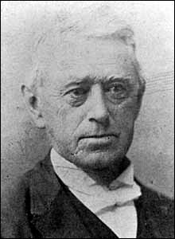
Charles Moody Atkinson was born on June 17, 1819, in Newburyport MA. He was an educator and school principal before he entered the seminary in 1845. He was ordained in 1849 and served churches in Mississippi, for more than 25 years, in 1867 was moderator of the Synod of Mississippi which included most of Mississippi and all of Louisiana, before going to Louisiana in 1874. In 1880 he went to Thibodaux where he resided for 8 years, continuing as "Evangelist of the Teche." He died in Centerville LA on Nov. 4, 1906. The church in Morgan City is named after him.

Fisher Ames Tyler was born in MA and came to Vicksburg in 1835, editing the newspaper. He was a lawyer in Grenada before becoming a minister at the Cincinnati Presbyterian Seminary in 1847. He was a Colonel in the Confederate Army on the staff of Gen Stirling Price. He returned to newspapers after the war and died in 1902 in Holly Springs. Buried in Memphis.
Edgar Morrison Richardson was born in 1828 in Camden County, NC, and graduated from Union Theological Seminary in NY. While serving Grenada (1852-1868) he was also a CSA Chaplain in the Civil War. After Grenada, he was pastor at Third Presbyterian in Memphis for the rest of his ministry. He died in 1897 and is buried in Memphis.
William E Holley was born in TN in 1808. He joined Eliot Mission in 1829 as a teacher. After Eliot closed, he attended Maryville Theological Seminary (Presbyterian) in TN and was ordained in September 1835. He then was a missionary to the Choctaws in OK in 1835-1836. After this, he was pastor at Middleton (Montgomery County now, Carroll County then) in 1837, Carrollton in 1840, and Lexington in 1843. He was the principal of the Presbyterian school operated in the Union Hotel in Grenada, and later taught at Grenada College. The 1850 Yalobusha County census shows him a “teacher”, born in TN in 1808, with a daughter born in MS in 1838. He had 3 slaves in 1850. He is in the 1840 Carroll County census with 10 slaves. He was brought up before Synod in 1856 as having slaves “by choice and principle”. He died in 1857. General Assembly minutes show him as a teacher at the Grenada church 1849-1857.
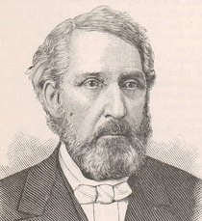
John R Fielder was a physician as well as a minister. According to Milton Winter, he died in the 1878 Yellow Fever epidemic in Grenada, but another source has his bill being settled in 1880, and he is not in the Hathorn list of those who died.
James Adair Lyon was born in 1814 in Jonesboro TN and graduated from Princeton Theological Seminary. In August 1870, Dr. Lyon was elected Professor of Mental and Moral Science in the University of Mississippi. He was pastor in Columbus for 16 years before coming to Grenada. He died in 1882 and is buried at Holly Springs.

The first regularly installed minister was Rev J C Carothers who became the minister in 1879 and served until 1918. He was born in South Carolina in 1844 but moved to Starkville at an early age. His parents are buried in Starkville. He served in Wirt Adams’ cavalry in the Civil War. His first pastorate was in Kemper County in 1874. He married Belle McCalebb of Scooba in 1879. He died in 1919 and is buried in Odd Fellows Cemetery in Grenada. It was during his ministry that the new church was built (1904-1905).
Rev Carothers was followed in 1919 by Rev J R Cunningham who was born in Missouri. Grenada was his first pastorate. He served until 1923.

PRESENT BUILDING

Fundraising for a new church building was started by 1897
First Presbyterian Church in Grenada is historically important as the oldest church building in Grenada – constructed in 1905 - hosting a congregation that goes back to the founding of the town in 1836 soon after the Choctaw cession in the Treaty of Dancing Rabbit Creek. One of the original members was William Hooe Winter Jr, great-grandfather of former Mississippi governor William Winter. The large stained-glass windows, over a hundred years old, are of significance in themselves, with the largest being in memorial to William Hooe Winter Jr. Another of these windows is in memorial to the Reverend John McCampbell, the church’s minister who died at his post in the 1878 yellow fever epidemic, when the congregation lost 26 members. The church has been at the same location at the intersection of Doak Street and Second Street since this lot was acquired in 1838. The earlier then-dilapidated wooden building was demolished in 1904 as construction of the present building began.
Grenada Presbyterian is the only church in town to still be on its original lot.

An article in the Grenada Sentinel on June 11, 1904, notes the award of the construction contract, with construction to start about July 1, 1904. Groundbreaking occurred on August 15, 1904 (Grenada Sentinel August 20, 1904).
The architect was L. M. Weathers of Memphis TN, as noted in the Grenada Sentinel on May 7, 1904. The advertisement for bids - with note of plans available for view at the office of L M Weathers in Memphis - was posted in the Grenada Sentinel on May 14, 21 and 28, 1904 and in the Industrial Development and Manufactures’ Record, Volume 45, page 410 (May 19, 1904).
Lundie Monroe Weathers practiced both under his own name and in association with his nephew Patrick Henry Weathers (MDAH Historic Resources Inventory Database).
The builder was Irby and Whitaker of Grenada, as noted in the Grenada Sentinel on June 11, 1904.
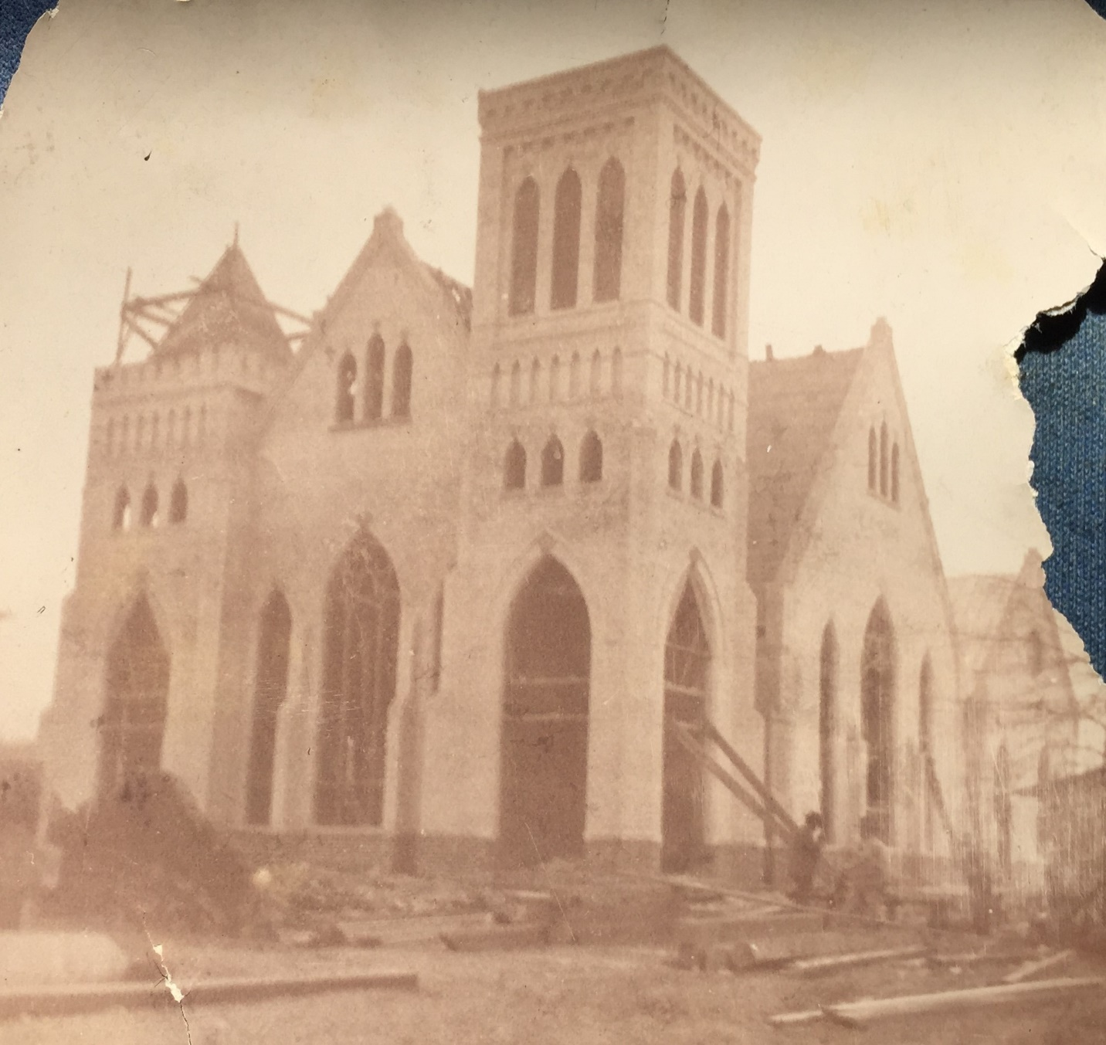

The church met in the City Hall and the city school building during the construction, and a downtown fire in May 1905 destroyed the Session records.
The first service in the completed building was on June 18, 1905, as noted in the Grenada Sentinel on June 24, 1905.
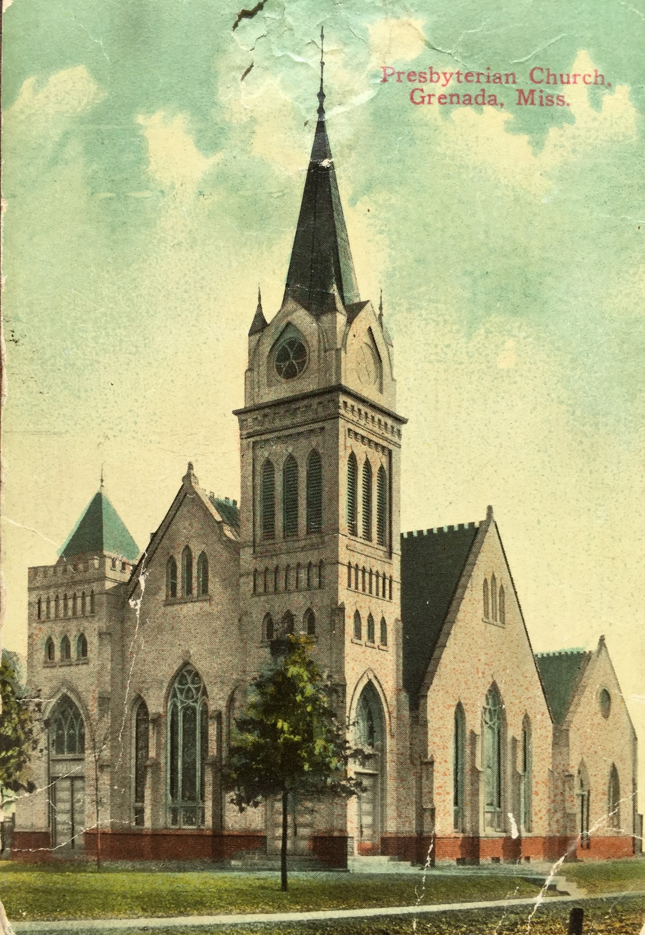
First Presbyterian Church in Grenada is a two-story sand-lime brick and stucco building, the stucco having been applied in later years to the original white brick exterior. Except for a smaller east classroom wing added in 1928-1929, the building is the original 1905 structure. The original section has a prominent square bell tower with wall buttresses, Gothic arched windows with label molding, Gothic arch vent windows and a blind Gothic arch arcade. At the roofline is a corbelled brick cornice and a conical roof with finials. The roof is the original pressed metal. On the northwest corner is a small tower with pyramidal roof.
The sanctuary contains large Gothic arched stained-glass windows and wall buttresses, and small stained-glass windows in the gable – 46 in all and all original. The Highgate window is a memorial to Robert and Jeanie M Highgate who came from Scotland. Mrs Highgate held the church together after the 1878 Yellow Fever epidemic. The Moore window is a memorial to John and Mary Moore. John Moore was an original Trustee of the church and built the first building in 1838. The Rev John McCampbell window honors the church’s minister who died at his post in the 1878 Yellow Fever epidemic. The William H and Elvira Winter window is a memorial to the great-grandparents of Gov William Winter, a child of the church.

The pipe organ was installed in 1912: Opus 1077 of the Estey Organ Company of Brattleboro, Vermont (Organ Historical Society Database - OHS Database ID 48264). Carnegie funds supplemented those raised by the church. The organ was rebuilt in 1958 but is not playable now.

On May 20, 1928, the Session approved planning for the addition of the Sunday School annex on the east side. On June 3, 1928, the Session accepted the plans of architect Hugh L Neven of Louisville KY for the addition with a cost of $20,000. Repainting and renovation of the exterior and interior of the existing building was included in this work. The addition was approved at a Congregational meeting on February 17, 1929. The exterior stucco was apparently applied over the original white brick in the 1929 renovation.

Some renovation was done to the sanctuary in 1952 - new carpet, new lights, new ceiling tiles – but the original appearance was preserved. The 1928 addition was remodeled at this time. Various needed repairs against moisture damage in the roof and walls have been done in recent years.

First Presbyterian Church (1905) in Grenada is architecturally important as an example of very early 20th century Gothic Revival architecture in Mississippi, and it has escaped proper notice in this regard - although it is the work of the same architectural association that did St Peter’s Cathedral (1900) and St Andrew’s Episcopal Church (1903) in Jackson (MDAH Historic Resources Inventory Database). These turn-of-the-century churches are of architectural significance between the Gothic Revival churches of the 19th century and the Neogothic churches of the later 20th century.

First Presbyterian Church is included in the Grenada Downtown Historic District that was added to the National Register of Historic Places in 2014.

Windows

William H Winter (1817-1880) Born in AL. Buried in Odd Fellows, Grenada.
Robert (1824-1888) & Jeanie (1832-1897) Highgate. Both born in Scotland. Buried in Odd Fellows, Grenada.
Robertson Horton (1801-1878) Adelaide Townes great-grandfather. Born in NC. Bought several parcels of land in 1833, between Grenada and Graysport (near present lake edge at Carver Point). His brother was a Baptist minister in NC. Buried in Horton Cemetery, Grenada.
Samuel H Cowles (1826-1870) Adelaide Townes great-grandfather. Born in NH. Buried in Odd Fellows, Grenada.
Mary Elizabeth Hart Ayres (1844-1904). Born in Carroll County. Married William Ayres in Carroll Co in 1876. Buried in Odd Fellows, Grenada.
Ayres Family: Angus W Ayres (1816-1878). Born in OH. Buried in Odd Fellows, Grenada.

RESOURCES

A Brief History of Presbyterian Congregation in Grenada, Rev J R Cunningham, Grenada Sentinel, November 28, 1919, p.13.
https://chroniclingamerica.loc.gov/lccn/sn85034375/1919-11-28/ed-1/seq-13/#date1=1919&index=2&date2=1919&searchType=advanced&language=&sequence=0&lccn=sn85034375&words=Church+Presbyterian&proxdistance=5&state=Mississippi&rows=20&ortext=&proxtext=&phrasetext=Presbyterian+church&andtext=&dateFilterType=yearRange&page=1

History of Grenada County, Mississippi, J C Hathorn, 1968, Southern Historical Press reprint, 2015
http://www.msgw.org/grenada/historyofgrenadacounty-jhathorn.html

Family Maps of Grenada County, Mississippi, Gregory A Boyd, Arphax Publishing Co, 2006

Biographical and Historical Memoirs of Mississippi: Embracing an Authentic and Comprehensive Account of the Chief Events in the History of the State and a Record of the Lives of Many of the Most Worthy and Illustrious Families and Individuals
https://books.google.com/books?id=G-pEAQAAMAAJ

Find a Grave
https://www.findagrave.com/

Family Search (Mormon genealogy site) – census, marriage, etc
https://www.familysearch.org/

Chronicling America – Grenada Sentinel
https://chroniclingamerica.loc.gov/

MDAH Historic Maps
http://www.mdah.ms.gov/arrec/digital_archives/series/maps

Minutes of the General Assembly of the Presbyterian Church in the United States of America (1838-1867)
https://catalog.hathitrust.org/Record/006774771

1878 Yellow Fever Epidemic - Grenada Report (p.160-166), Death List (p.162-4)
https://ia801402.us.archive.org/27/items/65030600R.nlm.nih.gov/65030600R.pdf

1878 Yellow Fever Epidemic Death List - Grenada
http://sites.rootsweb.com/~msgrenad/grenyfvr.htm

